**Practical 1**

**Aim: To design a two-column representation of text-based question using <table> and <p>.**

**Code:**

<!DOCTYPE html>

<html>

<head>

    <meta charset="utf-8">

    <meta name="viewport" content="width=device-width, initial-scale=1">

    <title>First Page</title>

</head>

<body>

    <table width="100%">

        <tr>

            <td width="50%">

                <p>Lorem ipsum dolor sit amet, consetetur sadipscing elitr, sed diam nonumy eirmod tempor invidunt ut labore et dolore magna aliquyam erat, sed diam voluptua. At vero eos et accusam et justo duo dolores et ea rebum. Stet clita kasd gubergren, no sea takimata sanctus est Lorem ipsum dolor sit amet. Lorem ipsum dolor sit amet, consetetur sadipscing elitr, sed diam nonumy eirmod tempor invidunt ut labore et dolore magna aliquyam erat, sed diam voluptua. At vero eos et accusam et justo duo dolores et ea rebum. Stet clita kasd gubergren, no sea takimata sanctus est Lorem ipsum dolor sit amet.</p>

            </td>

            <td width="50%">

                <p align="right">

                    Question: But I must explain to you how all this mistaken idea of denouncing pleasure and praising pain was born

                    <br>

                    <br>

                    A I will give you a complete account of the system, and expound the actual teachings of the great explorer of the truth, the master-builder of human happiness.

                    <br>

                    <br>

                    B But I must explain to you how all this mistaken idea of denouncing pleasure and praising pain was born

                    <br><br>

                    C  I will give you a complete account of the system, and expound the actual teachings of the great explorer of the truth, the master-builder of human happiness.

                    <br><br>

                    D  I will give you a complete account of the system, and expound the actual teachings of the great explorer of the truth, the master-builder of human happiness.

                </p>

            </td>

        </tr>

    </table>

</body>

</html>

**Output-**

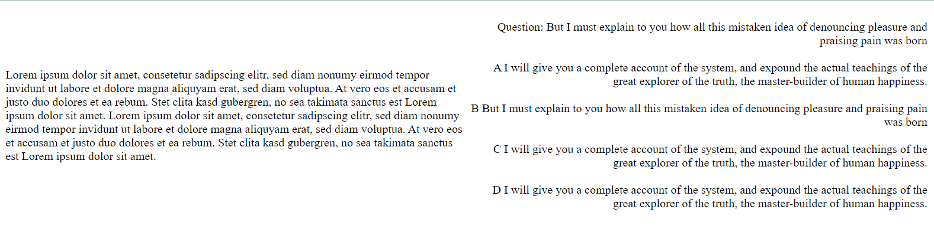

**Aim2: To implement various different input types and <select> tag.**

**Code:**

<!DOCTYPE html>

<head>

<meta charset="utf-8">

<meta name="viewport" content="width=device-width, initial-scale=1">

<title>Login Page</title>

</head>

<body>

<form>

<div align="center">

<div> <label for="user" > Username :</label>

<input type="text" placeholder="Enter your username" id="user" >

</div>

<br>

<label for=""> Password :</label>

<input type="password" name="pass"> <br> <br>

<label for="">Enter your current year :</label> <br>

<table>

<tr>

<td>

<input type="radio" name="opt1">

</td>

<td>

<label for=""> First year</label>

</td>

</tr>

<tr>

<td>

<input type="radio" name="opt1">

</td>

<td>

<label for=""> Second year</label>

</td>

</tr>

<tr>

<td>

<input type="radio" name="opt1">

</td>

<td>

<label for=""> Third year</label>

</td>

</tr>

<tr>

<td>

<input type="radio" name="opt1">

</td>

<td>

<label for=""> Fourth year</label>

</td>

</tr>

</table>

<label > Select any two of the subject :</label> <br>

<input type="checkbox" name="first" >

<label for=""> JAva</label>

<input type="checkbox" name="first" >

<label for=""> AJP</label>

<input type="checkbox" name="first" >

<label for=""> WD</label> <br> <br>

<div>

<label for=""> Tell us something about yourself :</label> <br>

<textarea cols="30" rows="10"></textarea>

</div>

<label for="">Enter your birth date :</label>

<input type="date" name="" id=""> <br> <br>

<label for="">Upload your marksheet</label>

<input type="file" name="" id=""> <br> <br>

<label for="">Select your branch</label>

<select name="branch" id="mybranch">

<option value="it">IT</option>

<option value="cp">Cp</option>

<option value="ec">EC</option>

<option value="ft">FPT</option>

</select> <br> <br>

<input type="submit" value="Submit Now"> <br> <br>

<input type="reset" name="res" id="res">

</div>

</form>

</body>

</html>

**Output:**

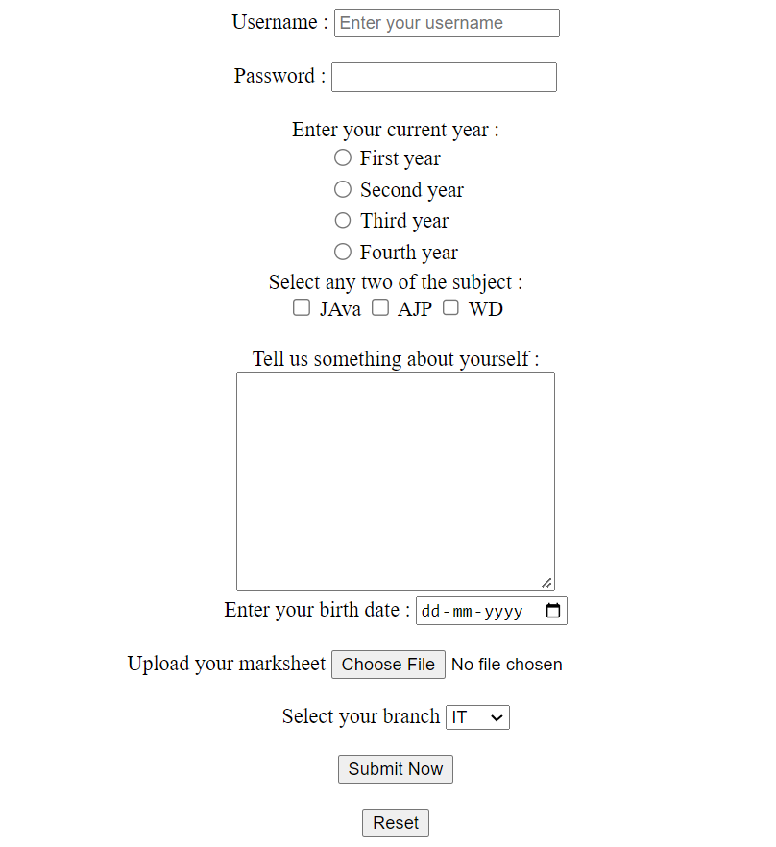

**Practical 2**

**Aim: To learn the use of <a> </a> anchor tag and link different web pages.**

**Code1:**

<!DOCTYPE html>

<html>

<head>

</head>

<body>

<h1>First Page</h1>

<a href="second.html"> Next</a> <br><br>

To Know more : <a href="help.html" target="_blank">Click here</a>

</body>

</html>

**Output:**



**Code:**

<!DOCTYPE html>

<html>

<head>

</head>

<body>

<h1>Second Page</h1>

<a href="third.html"> Next</a> <br>

<a href="first.html"> Previous</a> <br><br>

To Know more : <a href="help.html" target="_blank">Click here</a>

</body>

</html>

**Output:**



**Code:**

<!DOCTYPE html>

<html>

<head>

</head>

<body>

<h1>Third Page</h1>

<a href="fourth.html"> Next</a> <br>

<a href="second.html"> Previous</a> <br><br>

To Know more : <a href="help.html" target="_blank">Click here</a>

</body>

</html>

**Output:**



**Code:**

<!DOCTYPE html>

<html>

<head>

</head>

<body>

<h1>Fourth Page</h1>

<a href="third.html"> Previous</a> <br>

<a href="first.html"> Home</a> <br><br>

To Know more : <a href="help.html" target="_blank">Click here</a>

</body>

</html>

**Output:**



**Code:**

<!DOCTYPE html>

<head>

</head>

<body>

<h1>Help!</h1>

</body>

</html>

**Output:**

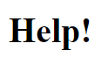

**Aim2: To learn the use of meta tag and its attributes.**

**Code:**

<!DOCTYPE html>

<html>

<head>

<meta charset="utf-8">

<meta http-equiv="X-UA-Compatible" content="IE=edge">

<title></title>

<meta name="description"

content="This is the official website of A D Patel Institute of Technology. It is an official college of gujarat There are 8 branches for bachelor degree">

<meta name="author" content="Vikram Mali">

<meta name="keywords" content="best engineering college, gujarat college, food processing, anand, vvnagar, cvmu, gcet,mbit ">

<meta name="viewport" content="width=device-width, initial-scale=1">

<link rel="stylesheet" href="">

<meta http-equiv="refresh" content="5">

</head>

<body>

<h1>Welcome to Adit College</h1>

</body>

</html>

**Output:**



**Practical 3**

**Aim: To add css to buttons and learn about active and hover properties.**

**Code:**

<!DOCTYPE html>

<html lang="en">

<head>

<meta charset="UTF-8">

<meta http-equiv="X-UA-Compatible" content="IE=edge">

<meta name="viewport" content="width=device-width, initial-scale=1.0">

<title>Button</title>

<style>

.btn1{

font-size: 25px;

border-radius: 5px;

border: none;

background-color: rgb(142, 222, 195);

padding:15px;

margin-left: 10px;

box-shadow: 0px 4px 6px 0px rgba(0, 0, 0, 0.6);

}

.btn1:active{

box-shadow: 0px 4px 6px 0px rgba(0, 0, 0, 0.2);

border-radius: 5px;

}

.btn2{

font-size: 25px;

border: none;

/* background-color: rgb(128, 102, 231); */

background-image: linear-gradient(rgb(233, 237, 18),rgb(216, 118, 73));

padding:15px;

margin-left: 10px;

box-shadow: 0px 4px 6px 0px rgba(0, 0, 0, 0.8);

}

.btn2:active{

border-radius: 3px;

box-shadow: 0px 4px 6px 0px rgba(0, 0, 0, 0.2), inset 1px 1px 1px 3px rgba(0, 0, 0, 0.4);

background-image: linear-gradient(rgba(236, 239, 70, 0.611),rgb(240, 83, 10));

}

.btn3{

font-size : 25px;

background-image: linear-gradient(rgb(47, 255, 141),rgb(27, 138, 75));

padding: 15px;

border: none;

margin-left: 10px;

box-shadow:0 4px 6px 0 rgba(0,0,0,0.8) , 0 4px 6px 0 rgba(0,0,0,0.8) ;

}

.btn3:active{

background-image: linear-gradient(rgb(47, 255, 141),rgb(11, 73, 38));

border: none;

box-shadow:0 4px 6px 0 rgba(0,0,0,0.4) , 0 4px 6px 0 rgba(0,0,0,0.4) ;

}

</style>

</head>

<body>

<button class="btn1">Click here</button>

<br><br>

<button class="btn2">Click here</button>

<br><br>

<button class="btn3">Click here</button>

</body>

</html>

**Output:**

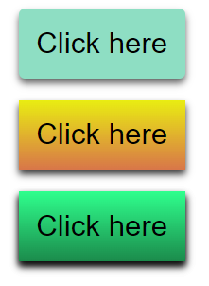

**Practical 4**

**Aim: Creating a class for applying CSS to table and special effects to <tr> and also applying the box shadow to same.**

**Code:**

<!DOCTYPE html>

<html lang="en">

<head>

<meta charset="UTF-8">

<meta http-equiv="X-UA-Compatible" content="IE=edge">

<meta name="viewport" content="width=device-width, initial-scale=1.0">

<title>Welcome Player</title>

<link rel = "icon" href = "1280px-AcetoFive.jfif" type = "image/x-icon">

<style>

.table1{

width: 200px;

border: 2px solid ;

box-shadow: 10px 15px 20px 2px rgb(27, 27, 21);

border-collapse:collapse;

position: absolute;

top: 200px;

left: 200px;

transform: rotate(0deg);

}

.row{

border-collapse: collapse;

border: 1px solid rgb(229, 227, 107);

}

.first{

height: 100px;

background-color: bisque;

box-shadow: 0px 4px 6px 0px rgba(255, 255, 201);

}

.second{

background-color: beige;

height:50px;

}

.pos1{

position: absolute;

top: 188px;

left: 220px;

transform: rotate(10deg);

}

.pos2{

position: absolute;

top: 180px;

left: 243px;

transform: rotate(20deg);

}

</style>

</head>

<body>

<table class="table1 pos2 ">

<tr >

<td class="row first">1</td>

</tr>

<tr >

<td class="row second">2</td>

</tr>

<tr >

<td class="row second">3</td>

</tr>

<tr >

<td class="row second">4</td>

</tr>

</table>

<table class="table1 pos1 ">

<tr >

<td class="row first">1</td>

</tr>

<tr >

<td class="row second">2</td>

</tr>

<tr >

<td class="row second">3</td>

</tr>

<tr >

<td class="row second">4</td>

</tr>

</table>

<table class="table1 ">

<tr >

<td class="row first">1</td>

</tr>

<tr >

<td class="row second">2</td>

</tr>

<tr >

<td class="row second">3</td>

</tr>

<tr >

<td class="row second">4</td>

</tr>

</table>

</body>

</html>

**Output-**

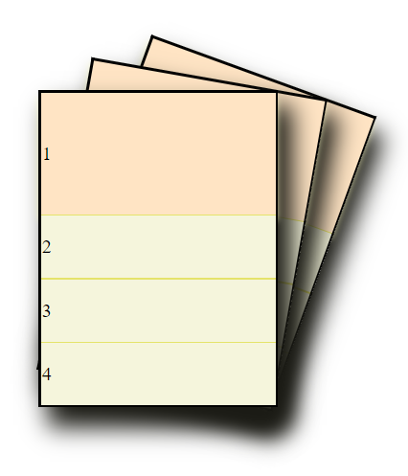

**Practical 5**

**Aim: To study transform and position properties in css.**

**Code:**

<!DOCTYPE html>

<html lang="en">

<head>

<meta charset="UTF-8">

<meta http-equiv="X-UA-Compatible" content="IE=edge">

<meta name="viewport" content="width=device-width, initial-scale=1.0">

<title>Document</title>

<style>

.td1{

border-bottom: 2px solid black;

}

.pos1{

position: absolute;

top: 200px;

left: 500px;

transform: rotate(-45deg);

}

.pos2{

position: absolute;

top: 200px;

left: 500px;

transform: rotate(45deg);

padding: 0px;

margin: 0px;

}

.second{

transform: rotate(180deg);

/*

position: absolute;

top: 10px;

left: 20px; */

}

</style>

</head>

<body>

<table width="25%" class="pos1">

<tr>

<td align="left" class="td1"><span>ADIT</span>

</td>

</tr>

<tr class="second ">

<td ><span>ADIT</span></td>

</tr>

</table>

<table width="25%" class="pos2">

<tr>

<td align="left" class="td1"><span>ADIT</span>

</td>

</tr>

<tr class="second">

<td><span>ADIT</span></td>

</tr>

</table>

</body>

</html>

**Output:**

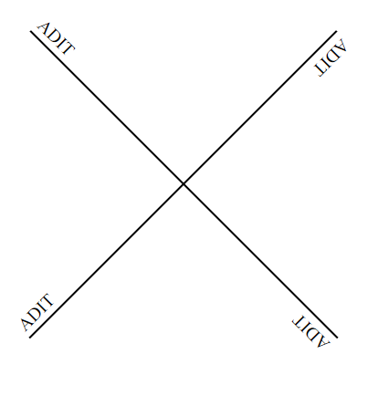

**Practical 6**

**Aim: To study basic overlay effect.**

**Code:**

<!DOCTYPE html>

<html lang="en">

<head>

<meta charset="UTF-8">

<meta http-equiv="X-UA-Compatible" content="IE=edge">

<meta name="viewport" content="width=device-width, initial-scale=1.0">

<title>Document</title>

<style>

.work{

width: 300px;

height: 300px;

background-color:bisque;

background-image: url("images.jpg");

background-size: cover;

}

.work1{

height: 50px;

width: 100%;

font-size: 29px;

font-family: 'Franklin Gothic Medium', 'Arial Narrow', Arial, sans-serif;

text-align: center;

background-image: linear-gradient(rgba(93, 176, 139, 0.8), rgba(20, 62, 43, 0.4));

}

.work2{

height: 50px;

width: 100%;

background-color:cadetblue;

position: relative;

top:80%;

font-size: 29px;

text-align: center;

background-image: linear-gradient(rgba(0,0,0,0.5), rgba(0,0,0,0.2));

}

.work1:hover{

background-image: linear-gradient(rgb(93, 176, 139), rgba(20, 62, 43, 0.785));

}

</style>

</head>

<body>

<div class="work">

<div class="work1"> <span> Hello ADIT </span></div>

<div ></div>

<div class="work2">

<span>Welcome</span>

</div>

</div>

</body>

</html>

**Output:**

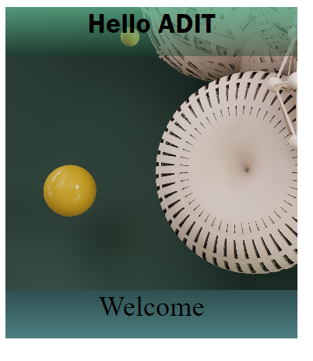

**Practical 7**

**Aim: To learn to apply media query and its application.**

**Code:**

<!DOCTYPE html>

<html lang="en">

<head>

<meta charset="UTF-8">

<meta http-equiv="X-UA-Compatible" content="IE=edge">

<meta name="viewport" content="width=device-width, initial-scale=1.0">

<title>Document</title>

<style>

.first{

height: 500px;

width: 15%;

background-color: rgb(3, 105, 71);

float: right;

}

.second{

height: 500px;

width: 70%;

float: right;

background-color: rgb(26, 232, 163);

}

.third{

height: 500px;

width: 15%;

background-color: rgb(3, 105, 71);

float: right;

}

@media only screen and (max-width: 800px) {

.first{

height: 100px;

width: 30%;

background-color: rgb(3, 105, 71);

float: none;

}

.second{

height: 100px;

width: 30%;

background-color: rgb(26, 232, 163);

float: none;

}

.third{

float: none;

height: 100px;

width: 30%;

background-color: rgb(3, 105, 71);

}

}

</style>

</head>

<body>

<div class="first"></div>

<div class="second"></div>

<div class="third"></div>

</body>

</html>

**Output:**



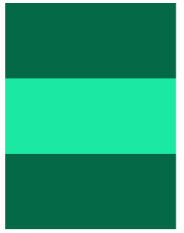

**Aim2: To create a navigation bar that shrinks into a vertical menu using media query.**

**Code:**

<!Doctype html>

<html lang="en">

<head>

<meta charset="utf-8">

<meta http-equiv="X-UA-Compatible" content="IE=edge">

<meta name="viewport" content="width=device-width,minimum-scale=1,initial-scale=1">

<style>

.home{

background-color:rgb(218,8,18);

text-align: center;

line-height: 32px;

font-size:large;

color:rgb(255,255,255);

width:9.09%;

float:right;

height:30px;

}

.home:hover{

background-color:rgb(117, 115, 115);

text-align: center;

font-size:large;

color:rgb(255,255,255);

}

.AboutUs{

background-color: rgba(142, 142, 142,0.5);

line-height: 32px;

text-align: center;

font-size:large;

width:9.09%;

float:right;

height:30px;

}

.AboutUs:hover{

background-color: rgba(117, 115, 115);

text-align: center;

font-size:large;

color:rgb(255,255,255);

}

.Programs{

background-color: rgba(142, 142, 142,0.5);

line-height: 32px;

text-align: center;

font-size:large;

width:9.09%;

float:right;

height:30px;

}

.Programs:hover{

background-color: rgba(117, 115, 115);

text-align: center;

font-size:large;

color:rgb(255,255,255);

}

.Courses{

background-color: rgba(142, 142, 142,0.5);

line-height: 32px;

text-align: center;

font-size:large;

width:9.09%;

float:right;

height:30px;

}

.Courses:hover{

background-color: rgba(117, 115, 115);

text-align: center;

font-size:large;

color:rgb(255,255,255);

}

.Placement{

background-color: rgba(142, 142, 142,0.5);

line-height: 32px;

text-align: center;

font-size:large;

width:9.09%;

float:right;

height:30px;

}

.Placement:hover{

background-color: rgba(117, 115, 115);

text-align: center;

font-size:large;

color:rgb(255,255,255);

}

.Admission{

background-color: rgba(142, 142, 142,0.5);

text-align: center;

font-size:large;

width:9.09%;

float:right;

height:30px;

}

.Admission:hover{

background-color: rgba(117, 115, 115);

text-align: center;

font-size:large;

color:rgb(255,255,255);

}

.StudentCorner{

background-color: rgba(142, 142, 142,0.5);

text-align: center;

font-size:large;

width:9.09%;

float:right;

height:30px;

}

.StudentCorner:hover{

background-color: rgba(117, 115, 115);

text-align: center;

font-size:large;

color:rgb(255,255,255);

}

.Research{

background-color: rgba(142, 142, 142,0.5);

text-align: center;

font-size:large;

width:9.09%;

float:right;

height:30px;

}

.Research:hover{

background-color: rgba(117, 115, 115);

text-align: center;

font-size:large;

color:rgb(255,255,255);

}

.AICTE{

background-color: rgba(142, 142, 142,0.5);

text-align: center;

font-size:large;

width:9.09%;

float:right;

height:30px;

}

.AICTE:hover{

background-color: rgb(82, 79, 79);

text-align: center;

font-size:large;

color:rgb(255,255,255);

}

.Campus{

background-color: rgba(142, 142, 142,0.5);

text-align: center;

font-size:large;

width:9.09%;

float:right;

height:30px;

}

.Campus:hover{

background-color: rgba(117, 115, 115);

text-align: center;

font-size:large;

color:rgb(255,255,255);

}

.Contact{

background-color: rgba(142, 142, 142,0.5);

text-align: center;

font-size:large;

width:9.09%;

float:right;

height:30px;

}

.Contact:hover{

background-color: rgba(117, 115, 115);

text-align: center;

font-size:large;

color:rgb(255,255,255);

}

@media only screen and (max-width:600px)

{

.home{

background-color:rgb(218,8,18);

text-align: center;

font-size:large;

color:rgb(255,255,255);

width:100%;

height:32px;

border-bottom: 1px solid;

}

.AboutUs{

background-color: rgba(142, 142, 142,0.5);

text-align: center;

font-size:large;

width:100%;

height:30px;

border-bottom: 1px solid;

}

.Programs{

background-color: rgba(142, 142, 142,0.5);

text-align: center;

font-size:large;

width:100%;

border-bottom: 1px solid;

height:30px;

}

.Courses{

background-color: rgba(142, 142, 142,0.5);

text-align: center;

font-size:large;

width:100%;

height:30px;

border-bottom: 1px solid;

}

.Placement{

background-color: rgba(142, 142, 142,0.5);

text-align: center;

font-size:large;

width:100%;

height:30px;

border-bottom: 1px solid;

}

.Admission{

background-color: rgba(142, 142, 142,0.5);

text-align: center;

font-size:large;

width:100%;

border-bottom: 1px solid;

height:30px;

}

.StudentCorner{

background-color: rgba(142, 142, 142,0.5);

text-align: center;

font-size:large;

width:100%;

height:30px;

border-bottom: 1px solid;

}

.Research{

background-color: rgba(142, 142, 142,0.5);

text-align: center;

font-size:large;

width:100%;

height:30px;

border-bottom: 1px solid;

}

.AICTE{

background-color: rgba(142, 142, 142,0.5);

text-align: center;

font-size:large;

width:100%;

height:30px;

border-bottom: 1px solid;

}

.Campus{

background-color: rgba(142, 142, 142,0.5);

text-align: center;

font-size:large;

width:100%;

height:30px;

border-bottom: 1px solid;

}

.Contact{

background-color: rgba(142, 142, 142,0.5);

text-align: center;

font-size:large;

width:100%;

height:30px;

border-bottom: 1px solid;

}

}

</style>

</head>

<body>

<div class="home"> Home</div>

<div class="AboutUs"> About Us</div>

<div class="Programs">Programs </div>

<div class="Courses"> Courses</div>

<div class="Placement"> Placement</div>

<div class="Admission"> Admission</div>

<div class="StudentCorner"> Student Corner</div>

<div class="Research"> Research/COE</div>

<div class="AICTE"> AICTE Idea Lab</div>

<div class="Campus"> Campus</div>

<div class="Contact">Contact</div>

<br><br>

</body>

</html>

**Output:**



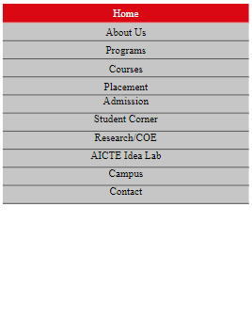

**Practical 8**

**Aim: Creating animation using keyframes and learning the use of animation-duration.**

**Code:**

<!DOCTYPE html>

<html lang="en">

<head>

<meta charset="UTF-8">

<meta http-equiv="X-UA-Compatible" content="IE=edge">

<meta name="viewport" content="width=device-width, initial-scale=1.0">

<style>

@keyframes switch2{

0% {

transform: rotate(0deg);

}

10% {

transform: rotate(45deg);

}

20% {

transform: rotate(-45deg);

}

30% {

transform: rotate(30deg);

}

40% {

transform: rotate(-30deg);

}

50% {

transform: rotate(20deg);

}

60% {

transform: rotate(-20deg);

}

70% {

transform: rotate(10deg);

}

80% {

transform: rotate(-10deg);

}

90% {

transform: rotate(5deg);

}

100% {

transform: rotate(0deg);

}

}

.btn2{

animation: switch2;

animation-duration: 6s;

position: absolute;

top: 150px;

left: 50px;

padding: 10px;

font-size: 20px;

border-radius: 20px;

background-color: antiquewhite;

}

.btn2:hover{

background-color:cadetblue;

}

</style>

<title>Document</title>

</head>

<body>

<button class="btn2"> submit</button>

</body>

</html>

**Output:**

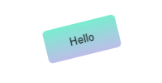

**Part 2: Code:**

<!DOCTYPE html>

<html lang="en">

<head>

<meta charset="UTF-8">

<meta http-equiv="X-UA-Compatible" content="IE=edge">

<meta name="viewport" content="width=device-width, initial-scale=1.0">

<style>

@keyframes switch3{

0% {

transform: rotate(0deg);

}

50% {

transform: rotate(1800deg);

}

75% {

transform: rotate(180deg);

}

100% {

transform: rotate(0deg);

}

}

.btn3{

position: absolute;

top: 20px;

left: 150px;

font-size: 20px;

margin: 10px;

padding: 10px;

border-radius: 20px;

background-color: antiquewhite;

}

.btn3:active{

animation: switch3;

animation-duration: 4s;

}

</style>

<title>Document</title>

</head>

<body>

<!-- <button class="btn"> submit</button> -->

<!-- <button class="btn2"> submit</button> -->

<button class="btn3"> submit</button>

</body>

</html>

**Output:**

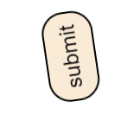

**Practical 9**

**Aim: Creating a color pallet using javascript.**

**Code:**

<!DOCTYPE html>

<html lang="en">

<head>

<meta charset="UTF-8">

<meta http-equiv="X-UA-Compatible" content="IE=edge">

<meta name="viewport" content="width=device-width, initial-scale=1.0">

<title>Layers</title>

<style>

.maintab{

border-collapse: collapse;

}

</style>

</head>

<body>

<table class="maintab" width="30%" height="200px">

<script>

var i,a,b,c;

a=30;

b=20;

c=40;

for(i=0;i<=6;i++)

{

document.write("<tr>");

document.write("<td style=\"background-color:rgb("+a+","+b+","+c+");\"></td>");

document.write("</tr>");

a=a+25;

b=b+26;

c=c+24;

}

</script>

</table>

</body>

</html>

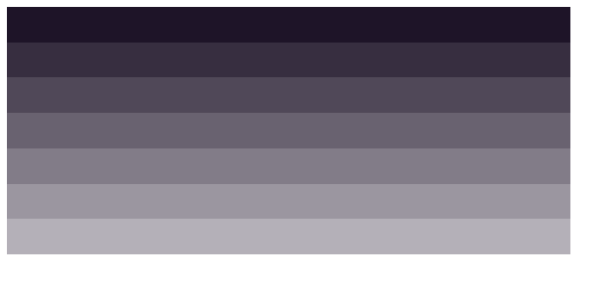**Output:**

**Practical 10**

**Aim: Creating a simple calculator using JavaScript.**

**Code:**

<!DOCTYPE html>

<html lang="en">

<head>

<meta charset="UTF-8">

<meta http-equiv="X-UA-Compatible" content="IE=edge">

<meta name="viewport" content="width=device-width, initial-scale=1.0">

<title>Document</title>

<script>

var n1,n2,v3;

function add()

{

n1 = document.getElementById("n1").value;

n2 = document.getElementById("n2").value;

n3 = parseFloat(n1) + parseFloat(n2);

document.getElementById("Ans").innerHTML=n3;

}

function sub()

{

n1 = document.getElementById("n1").value;

n2 = document.getElementById("n2").value;

n3 = parseFloat(n1) - parseFloat(n2);

document.getElementById("Ans").innerHTML=n3;

}

function mul()

{

n1 = document.getElementById("n1").value;

n2 = document.getElementById("n2").value;

n3 = parseFloat(n1) * parseFloat(n2);

document.getElementById("Ans").innerHTML=n3;

}

function div()

{

n1 = document.getElementById("n1").value;

n2 = document.getElementById("n2").value;

if(n2 != 0 )

{

n3= parseFloat(n1) / parseFloat(n2);

document.getElementById("Ans").innerHTML=n3;

}

else

{

document.getElementById("Ans").innerHTML="Error";

}

}

</script>

</head>

<body>

<label>Number 1:</label>

<input type="number" id="n1"><br><br>

<label>Number 2:</label>

<input type="number" id="n2"><br><br>

<button onclick="add()">ADD</button> <br><br>

<button onclick="sub()">SUBTRACT</button> <br><br>

<button onclick="mul()">MULTIPLY</button><br><br>

<button onclick="div()">DIVIDE</button> <br>

Ans:

<span id="Ans">

</span>

</body>

</html>

**Output:**

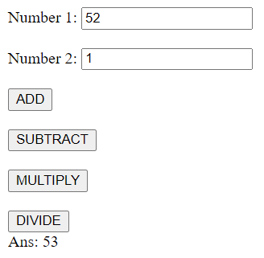

**Aim2: Creating a game of tic-tac-toe using javascript.**

**Code:**

<!DOCTYPE html>

<html lang="en">

<head>

<meta charset="UTF-8">

<meta http-equiv="X-UA-Compatible" content="IE=edge">

<meta name="viewport" content="width=device-width, initial-scale=1.0">

<title>Document</title>

<style>

.main{

margin-left: 50px;

border-collapse: collapse;

}

.subtab{

border:1px solid;

height:50px;

width:50px;

}

</style>

<script>

function x1()

{

document.getElementById("hellox1").innerHTML="X";

}

function x2()

{

document.getElementById("hellox2").innerHTML="X";

}

function x3()

{

document.getElementById("hellox3").innerHTML="X";

}

function x4()

{

document.getElementById("hellox4").innerHTML="X";

}

function x5()

{

document.getElementById("hellox5").innerHTML="X";

}

function x6()

{

document.getElementById("hellox6").innerHTML="X";

}

function x7()

{

document.getElementById("hellox7").innerHTML="X";

}

function x8()

{

document.getElementById("hellox8").innerHTML="X";

}

function x9()

{

document.getElementById("hellox9").innerHTML="X";

}

function y1()

{

document.getElementById("hellox1").innerHTML="O";

}

function y2()

{

document.getElementById("hellox2").innerHTML="O";

}

function y3()

{

document.getElementById("hellox3").innerHTML="O";

}

function y4()

{

document.getElementById("hellox4").innerHTML="O";

}

function y5()

{

document.getElementById("hellox5").innerHTML="O";

}

function y6()

{

document.getElementById("hellox6").innerHTML="O";

}

function y7()

{

document.getElementById("hellox7").innerHTML="O";

}

function y8()

{

document.getElementById("hellox8").innerHTML="O";

}

function y9()

{

document.getElementById("hellox9").innerHTML="O";

}

</script>

</head>

<body>

<div>

X :

<button onclick="x1()">1</button>

<button onclick="x2()">2</button>

<button onclick="x3()">3</button>

<button onclick="x4()">4</button>

<button onclick="x5()">5</button>

<button onclick="x6()">6</button>

<button onclick="x7()">7</button>

<button onclick="x8()">8</button>

<button onclick="x9()">9</button>

</div>

<br>

<table class="main" border="1">

<tr>

<td class="subtab" id="hellox1" align="center"></td>

<td class="subtab" id="hellox2" align="center"></td>

<td class="subtab" id="hellox3" align="center"></td>

</tr>

<tr>

<td id="hellox4" class="subtab" align="center"></td>

<td id="hellox5" class="subtab" align="center"></td>

<td id="hellox6" class="subtab" align="center"></td>

</tr>

<tr>

<td id="hellox7" class="subtab" align="center"></td>

<td id="hellox8" class="subtab" align="center"></td>

<td id="hellox9" class="subtab" align="center"></td>

</tr>

</table>

<br>

<div>

Y :

<button onclick="y1()">1</button>

<button onclick="y2()">2</button>

<button onclick="y3()">3</button>

<button onclick="y4()">4</button>

<button onclick="y5()">5</button>

<button onclick="y6()">6</button>

<button onclick="y7()">7</button>

<button onclick="y8()">8</button>

<button onclick="y9()">9</button>

</div>

</body>

</html>

**Output:**

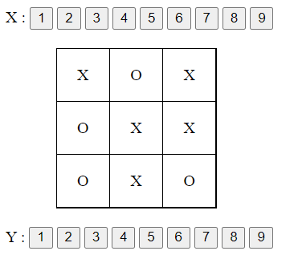

**Aim3: Overwriting button with a function in javascript.**

**Code:**

<!DOCTYPE html>

<html lang="en">

<head>

<meta charset="UTF-8">

<meta http-equiv="X-UA-Compatible" content="IE=edge">

<meta name="viewport" content="width=device-width, initial-scale=1.0">

<title>Overriding</title>

<script>

function hello()

{

// document.write("function called!");

document.getElementById("ab").innerHTML="Function called Above!";

document.getElementById("bl").innerHTML="Function called Below!";

}

</script>

</head>

<body>

<br>

<p id="ab">

</p>

<button onclick="hello();">click</button>

<p id="bl">

</p>

</body>

</html>

**Output:**

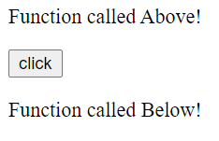

**Aim4: Checking the length of phone number using JavaScipt.**

**Code:**

<!DOCTYPE html>

<html lang="en">

<head>

<meta charset="UTF-8">

<meta http-equiv="X-UA-Compatible" content="IE=edge">

<meta name="viewport" content="width=device-width, initial-scale=1.0">

<title>Document</title>

<script>

function Student_Data()

{

var name;

name = document.getElementById("name").value;

pho = document.getElementById("phone").value;

if(pho.length != 10)

{

document.getElementById("error").innerHTML = "Phone Number is Invalid";

}

}

</script>

</head>

<body>

Name: <input type="text" id="name"><br><br>

Branch:<input type="text" id="branch"><br><br>

EnrollmentNo. :<input type="number" id="eno"><br><br>

Phone No. :<input type="number" id="phone"><br>

<p id="error"></p>

Email:<input type="email" id="email"><br><br>

<p id="para">

</p>

<button onclick="Student_Data()">Submit Data</button>

</body>

</html>

**Output:**

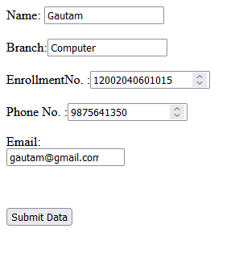

**Practical 11**

**Aim: To take input from user and find the length of it and slice it**

**Code:**

<!DOCTYPE html>

<html lang="en">

<head>

<meta charset="UTF-8">

<meta http-equiv="X-UA-Compatible" content="IE=edge">

<meta name="viewport" content="width=device-width, initial-scale=1.0">

<title>Document</title>

<script>

function func1()

{

var text1 = document.getElementById("name").value;

document.getElementById("p1").innerHTML=text1;

var text2 = text1.length;

document.getElementById("p2").innerHTML=text2;

//charAt

text2 = text1.charAt(2);

document.getElementById("p3").innerHTML=text2;

text2="ADIT";

text3 = text1.localeCompare(text2);

document.getElementById("p4").innerHTML=text3;

// Slicing - cutting the string from 3 of length 8

text3 = text1.slice(-3,8);

document.getElementById("p5").innerHTML=text3;

// substring

text3 = text1.substring(3,8);

document.getElementById("p6").innerHTML=text3;

// toUpperCase

text3 = text1.toUpperCase();

document.getElementById("p7").innerHTML=text3;

//replace

text3 = text1.replace("are","and");

document.getElementById("p8").innerHTML=text3;

}

</script>

</head>

<body>

<label>Name:</label>

<input type="text" id="name"><br><br>

<!-- <input type="text" id="email"> -->

<input type="submit" value="Submit Data" onclick="func1()">

<p id="p1"></p>

<p id="p2"></p>

<p id="p3"></p>

<p id="p4"></p>

<p id="p5"></p>

<p id="p6"></p>

<p id="p7"></p>

</body>

</html>

**Output:**

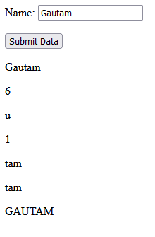

**Practical 12**

**Aim: To set a clock using JavaScript having start and stop buttons.**

**Code:**

<!DOCTYPE html>

<html lang="en">

<head>

<meta charset="UTF-8">

<meta http-equiv="X-UA-Compatible" content="IE=edge">

<meta name="viewport" content="width=device-width, initial-scale=1.0">

<title>Document</title>

<script>

var hour=0;

var min=0;

var sec=0;

function clock()

{

sec = sec + 1;

if(sec<60)

{

document.getElementById("clk").innerHTML=hour+":"+min+":"+sec;

}

else

{

min = min+1;

sec = 0;

if(min<60)

{

document.getElementById("clk").innerHTML = hour+":"+min+":"+sec;

}

else

{

hour = hour + 1;

min = 0;

document.getElementById("clk").innerHTML = hour+":"+min+":"+sec;

}

//windows.location.href do for some min and used to switch to new page.

}

}

</script>

</head>

<body>

<script>

function start()

{

const clock1 = setInterval(clock,1000);

}

function stop()

{

// document.getElementById("clk").innerHTML="0:0:0";

clearInterval(clock1);

}

</script>

<p id="clk">

</p>

<button onclick=start()>start</button>

<button onclick=stop()>stop</button>

</body>

</html>

**Output:**

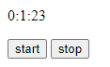

**Practical 13**

**Aim: Write a Sample Program in PHP**

**Code:**

* <!DOCTYPE html>

<html lang="en">

<head>

<meta charset="UTF-8">

<meta http-equiv="X-UA-Compatible" content="IE=edge">

<meta name="viewport" content="width=device-width, initial-scale=1.0">

<title>Document</title>

</head>

<body>

<?php

echo "<h1 align=\"center\">Hello, Welcome to PHP Program</h1></br>";

echo "<h1 align=\"center\">Computer Engineering, ADI</h1>"

?>

</body>

</html

**Output:**



**Aim: To store values in a variable and also print sum of 2 numbers.**

**Code:**

<!DOCTYPE html>

<html lang="en">

<head>

<meta charset="UTF-8">

<meta http-equiv="X-UA-Compatible" content="IE=edge">

<meta name="viewport" content="width=device-width, initial-scale=1.0">

<title>Document</title>

</head>

<body>

<?php

$a = "ADIT";

$b='c';

$x=14;

$y=102.55;

$z=$x+$y;

echo "<h1>The sum of the given number is</h1>" .$z;

?>

</body>

</html>

**Output:**

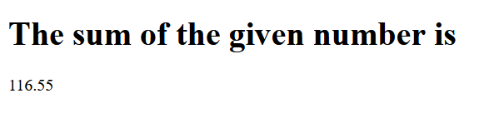

**Aim2: Checking session variables that were set on previous page.**

**Code:**

<?php

session_start();

?>

<!DOCTYPE html>

<html>

<body>

<?php

$_SESSION["col"] = "ADIT";

$_SESSION["branch"] = "CP";

?>

//Checking session variables<br>

<?php

// Echo session variables that were set on previous page

echo "Welcome, your college is " . $_SESSION["col"] . ".<br>";

echo "Your Branch is " . $_SESSION["branch"] . ".";

?>

</body>

</html>

**Output:**

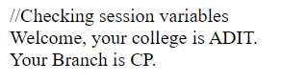

**Aim3: Printing a variable and converting it to upper case in php.**

**Code:**

<!DOCTYPE html>

<html lang="en">

<head>

<meta charset="UTF-8">

<meta http-equiv="X-UA-Compatible" content="IE=edge">

<meta name="viewport" content="width=device-width, initial-scale=1.0">

<title>Document</title>

</head>

<body>

<?php

$x = "adit college";

echo strtoupper($x);

?>

</body>

</html>

**Output:**

